

**Starters**

Watercress Soup - Roasted Garlic Oil £3.75

Wild Mushrooms - Chow Bun - Chive Soft Cheese £3.50

Scallops – Pea Puree – Cornish Hog’s Pudding – Pea Shoots £6.25

Pancetta, Sundried Tomato Olive Salad – Basil Oil £ 3.50

**Mains**

Crab, Red Onion, Coriander Linguine - Sweet Chilli Dressing - Parmesan £7.95

Cod Loin – Samphire - Polenta Cake - Saffron Reduction £7.50

Lamb Tagine – Couscous – Yogurt £6.95

Confit Duck – Orange Sauce - Wild Mushrooms - Lentil Stew £7.50

Asparagus Risotto – Poached Egg – Parmesan Shavings £6.75

**Desserts**

Classic Peach Melba

Passion Fruit Panacotta with Shortbread Biscuit

Chocolate Fondant with Orange Compote

Treacle Tart with Clotted Cream

All at £3.25

[](http://www.hospitalityguild.co.uk/Training-Development/Best-practice/Accreditation/Find-an-accredited-provider) [](http://explorebuxtonderbyshire.co.uk/best-western-leewood-hotel/429375_367773053257098_1452315956_n/) [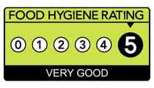](http://www.google.co.uk/url?sa=i&rct=j&q=&esrc=s&source=images&cd=&cad=rja&uact=8&ved=0ahUKEwiIrtqZgMjLAhWKvBQKHVDICRMQjRwIBw&url=http://www.cricketers-arms.co.uk/cricketers-arms-news&psig=AFQjCNEX8r1b-Hes4F5fAhc_u5AiYndkVQ&ust=1458313749213268) [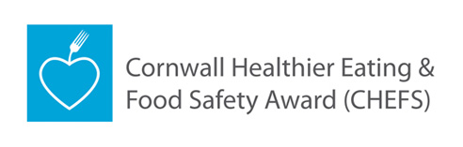](http://www.google.co.uk/url?sa=i&rct=j&q=&esrc=s&source=images&cd=&cad=rja&uact=8&ved=0ahUKEwiGttStgcjLAhXD1xQKHYwIDn0QjRwIBw&url=http://www.cornwall.gov.uk/chefs&psig=AFQjCNFJ7mLFMo8RJ_4lzzzHvGSJMBBV6Q&ust=1458313955458058) [](https://www.google.co.uk/url?sa=i&rct=j&q=&esrc=s&source=images&cd=&ved=0ahUKEwjGpKDhg8jLAhULuBQKHR6YDbsQjRwIBw&url=https://www.cornwall.ac.uk/trevenson-restaurant&psig=AFQjCNFbH9foWDYtjderBkIAanPnn8_9bQ&ust=1458314703213235)